Policy Council
January 23, 2024
10:00 am – 11:30 am
871 Stanley Ave, Family Center

Committee Purpose (per FSP Policy Council Bylaws):

The FSP Policy Council is “responsible for the direction of the Head Start program, including program design and operation, and long- and short-term planning goals and objectives, taking into account the annual community wide strategic planning and needs assessment and self-assessment.” [HSPPS 642 (c) (2) (A)]
The FSP Policy Council is also responsible for upholding the program mission statement: We partner with our families, schools, and communities to ensure each child arrives ready for Kindergarten.

- Welcome Heidi Calhoun

- Annual Audit Presentation & 990 (v) Erik Nichols

- Old Business

- September Minutes (v) Heidi Calhoun
- September/October/November/December Erik Nichols
Financial Reports & Credit Card Expenditures (v)

- New Business
1. Selection Criteria (v) Melisa Ostrowski
2. Corrective Action Plan Jessica Hatch
3. 45 Day Results Jessica Hatch
4. Hope from the Start Rebranding Carolyn Clouser
5. WOYC/MOYC draft Plan Melisa Ostrowski
6. Mid-Year Data Report Jessica Hatch
7. Officer Elections Carolyn Clouser

- Member Discussion/Questions/Suggestions

- Adjourn Heidi Calhoun

Upcoming Meetings: 2/27/2024, 3/26/2024, 4/23/2024, 5/21/2024, 6/25/2024

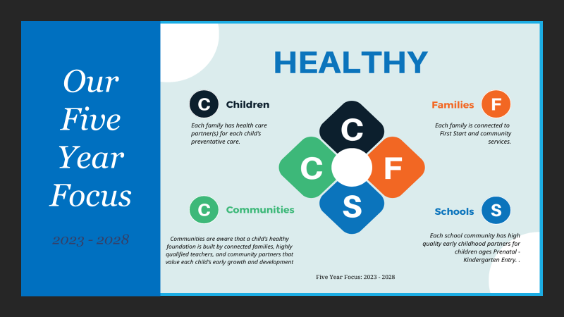

Our Mission:
We partner with our families, schools, and communities to ensure that each child arrives ready for kindergarten

