Policy Council
October 24, 2023
9:00 am – 10:30 am
871 Stanley Ave, Family Center

Committee Purpose (per FSP Policy Council Bylaws):

The FSP Policy Council is “responsible for the direction of the Head Start program, including program design and operation, and long- and short-term planning goals and objectives, taking into account the annual community wide strategic planning and needs assessment and self-assessment.” [HSPPS 642 (c) (2) (A)]
The FSP Policy Council is also responsible for upholding the program mission statement: We partner with our families, schools, and communities to ensure each child arrives ready for Kindergarten.

- Welcome Heidi Calhoun

- Old Business
- September Financial Reports & Jessica Kreigline
Credit Card Expenditures (v)
- Family Fun Day at Country Creek Jennifer Mercer

- New Business
1. Overview of Roles and Responsibilities Carolyn Clouser
2. Planning for 2023-2024 Program Year Heidi Calhoun
3. FSP Annual Report Carolyn Clouser
4. 2023 FSP Self-Assessment Carolyn Clouser

- Member Discussion/Questions/Suggestions

- Adjourn

Upcoming Meetings: 11/15/2023, 1/23/2024, 2/27/2024, 3/26/2024, 4/23/2024, 5/21/2024, 6/25/2024

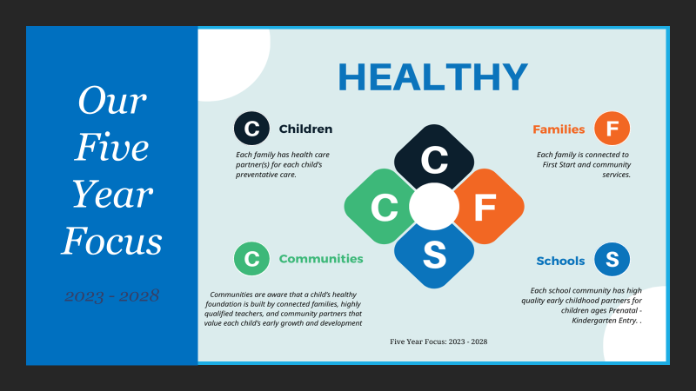

Our Mission:
We partner with our families, schools, and communities to ensure that each child arrives ready for kindergarten

