Policy Council
February 27, 2024
10:00 am – 11:30 am
871 Stanley Ave, Family Center

Committee Purpose (per FSP Policy Council Bylaws):

The FSP Policy Council is “responsible for the direction of the Head Start program, including program design and operation, and long- and short-term planning goals and objectives, taking into account the annual community wide strategic planning and needs assessment and self-assessment.” [HSPPS 642 (c) (2) (A)]
The FSP Policy Council is also responsible for upholding the program mission statement: We partner with our families, schools, and communities to ensure each child arrives ready for Kindergarten.

- Welcome Heidi Calhoun

- Old Business
- January Minutes (v) Heidi Calhoun
- January Financial Reports & Credit Card Erik Nichols
Expenditures (v)
- Officer Elections Carolyn Clouser

- New Business
      - NAEYC Self-Assessment and Program Improvement Annette Searfoss
Plan
      - Strategic Plan Update Carolyn Clouser
      - Fishing Derby Pamela Raynor
      - Safe Kids Action Plan Carolyn Clouser
      - Introduce Policy Council By-Laws Carolyn Clouser
      - Remind App Jennifer Mercer

- Member Discussion/Questions/Suggestions

- Adjourn Heidi Calhoun
Upcoming Meetings: 3/26/2024, 4/23/2024, 5/21/2024, 6/25/2024

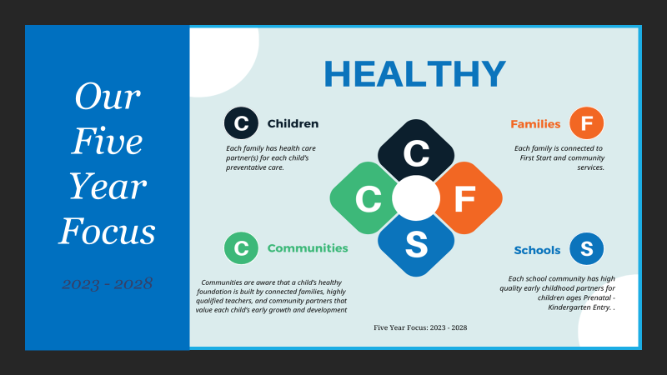

Our Mission:
We partner with our families, schools, and communities to ensure that each child arrives ready for kindergarten

