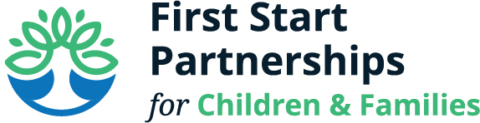
Policy Council
April 18, 2023
11:00 am

Policy Council Members Present: Steve Marvich, Heidi Calhoun, René Batres, Michelle Huber
FSP Staff Present: Jennifer Mercer, Carolyn Clouser, Annette Searfoss

- Annette shared that Heidi has agreed to serve as acting president. We will have a full vote at a later time. By having someone in this roll the meetings should be enhanced
- Annette shared a PowerPoint presentation surrounding the HS/EHS Grant Applications. Prior to the meeting Policy Council received the annual budget, COLA and QI information and the grant narratives.
- We are continuing to build on one goal of being nationally accredited through NAEYC. We are taking COVID into consideration and picking up where we left off. In January we will submit for an external validation team.
- Annette gave an overview and reminder of the process of how to get where we are today.
- NAEYC Self-Assessment was completed last November
- Community Assessments through WellSpan, Keystone and Improving the Early Education System in Franklin County
- What do we know about our current children and families (health, early learning, etc.)
- Our Five Year Focus will be on Healthy Children (Each Family has health care partners(s) for each child’s preventative care), Healthy Families (Each family is connected to First Start and community services), Healthy Communities (Communities are aware that a child’s healthy foundation is built by connected families, highly qualified teachers, and community partners that value each child’s early growth and development) and Healthy Schools (Each school community has high quality early childhood partners for children ages Prenatal-Kindergarten Entry).
- Optimizing Funding without Cutting Slots:
- Base Grant (See Annual Budget). Head Start and Early Head Start Budgets. Base grant of $3,742,349 plus a 20% Non-Federal Share.
- Number of classrooms remains consistent (14 HS, 3 EHS center-based, 48 home visiting)
- Consolidate 5 locations into one Lincoln Way Early Learning Center
- Expand full day pilot by braiding HS, HSSAP and PKC funding for full day (academic year)
- Budgeted for a 15% increase for health insurance effective January 2024
- COLA and Quality Improvement (See HS/EHS Projections). $316,178 total (added to base grant going forward).
- 5.6% COLA.
- 5 Additional Professional Development Days
- 3% annual increase for facilities and utilities
- Budgets due to be submitted by 4/21/2023
- Enrollment Reduction
- Data does not support Enrollment Reduction at this time.
- Will continue other options to increase salaries incrementally over five years (as Pre-K Counts allocations increase)
- In order to do everything surrounding salaries, we would have to reduce the number of children served by 105 children
- Organization Management Chart: Shared slide outlining the Organizations Management Chart. Pointed out that Policy Council is next to the President & CEO and there is a dotted line between the President & CEO and the Board of Directors.
- Steve Marvich made a motion to approve the HS/EHS grant as present. Michelle Huber seconded the motion. Motion passed.

Next Meeting: Tuesday, May 16, 2023 9:00-10:30 am

